1. CODE

|  |  |  |  |
| --- | --- | --- | --- |
| Name: | Cotacte, Ivan | Subject  Description: | Object-Oriented  Programming (3/1) |

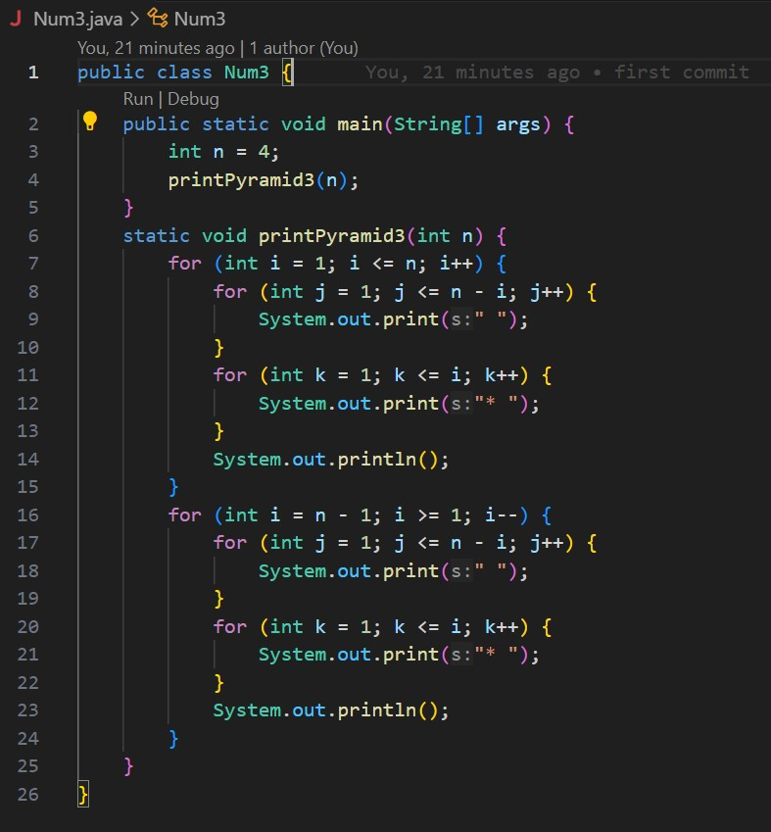

OUTPUT

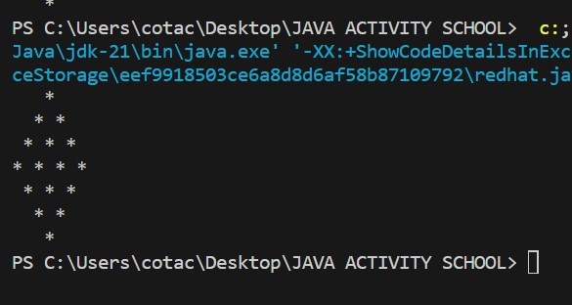

1. CODE

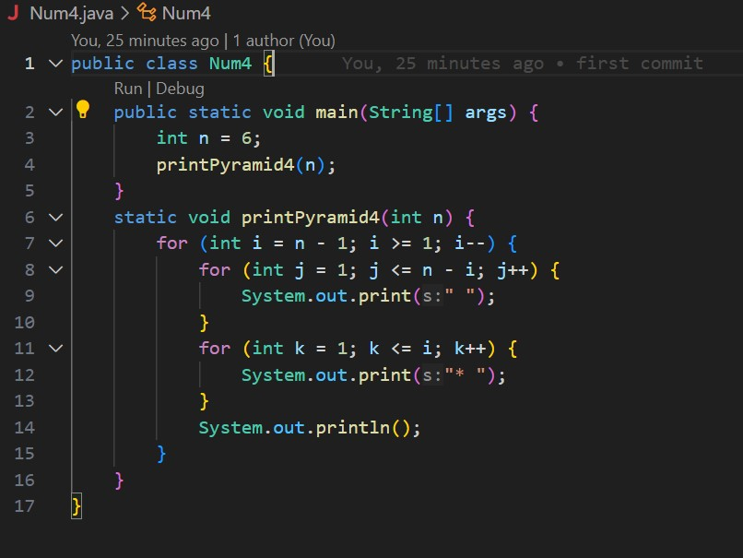

OUTPUT

